**First assignment. Santiago Navales Parra**

Considering the use that will be given to the distribution, where only a bash script with basic commands like grep or echo will be made, I have decided to use Ubuntu. Since it’s not necessary an administrative distribution or some which provides speed, due to just the file system will be used but not any specific program.

Now, once the distribution has been chosen, I have created a VM instance in GCP. I’ve decided to get my Linux system this way because I have no laptop, and most of the time I am at the University, and there I can’t install any virtualization tool. Accordingly, the best way to access a machine with all the files and facilities used during the School of DevOps is via SSH with GCP, where I’m using a 3 month free trial.

**Bash Script**

To solve the assignment with bash, I’ve created a script in a .sh file, where all the instructions are automated, and you can find and replace any word just by running the script. The editor in which I have written the files is Vim.

This is the files.

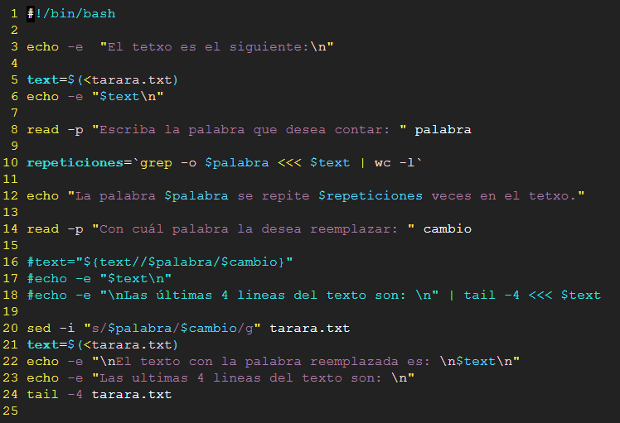The script is following:

The user is shown the contents of the *tarara.txt* file, then asked to enter the word he is looking for, to show him how many times it is repeated throughout the text. The user is then asked to enter the word with which he wants to replace the previously searched word.

Then, we proceed in two ways, from line 20 to 24 we replace the words in the tarara.txt file and display the contents of the modified file, plus its last 4 lines using the tail command.

On the other hand, between lines 16 and 18 the words are replaced in a variable, but not in the tarara.txt file (these are commented since they are two different ways to solve the problem, but they are not executed simultaneously). Then the modification of the variable containing the text string and its last 4 lines is shown.

**Output**

When running the script, we count “Tarara” 7 times in the text. If we wanted to count the word in a non-restrictive way is just necessary to add a “-i” in the grep at line 10. (then we wold have 9 tararas because of that with lowercase initial)

repeticiones=’grep -o -i $palabra <<< $text | wc -l’

The output is shown below:

**PowerShell Script**

To solve the assignment using Powershell, a script was created following the same logic, but in my personal windows system with Windows Powershell ISE.

And the output is below. Notice how special characters as tildes and “ñ” are not detected by the console.

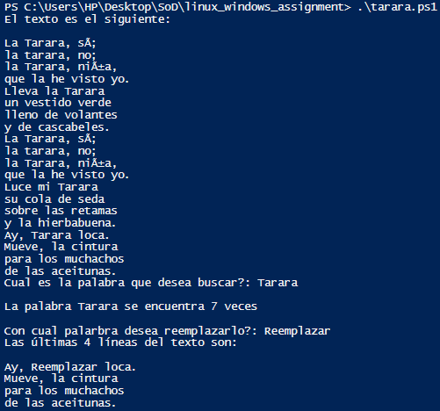

The output is the same as in the bash script :)

**Dates**

To get the date in format YY/MM/DD in both linux and windows terminal the command lines are stated:





**Powershell:** (Get-Date).ToString(“yyyy-MM-dd”)

**Bash:** date +%F